5E Template- Science
Name: Nichole Brumfield |  | Date: July 20, 2011
Content Area: Earth Science | Grade Level(s): 9th | Topic(s): Atmosphere

Standards (SOL)
E.S. 1 Students will plan and conduct investigations in which c) scales, diagrams, maps, charts, graphs, tables, and profiles are constructed and interpreted.
E.S. 2 The student will demonstrate scientific reasoning and logic by a) analyzing how science explains and predicts the interactions and dynamics of complex Earth systems.
E.S. 12 The student will investigate and understand the origin and evolution of the atmosphere and the interrelationship of geologic processes, biologic processes, and human activities on its composition and dynamics. Key concepts include a) scientific evidence for atmospheric changes over geologic time; b) current theories related to the effects of early life on the chemical makeup of the atmosphere; c) comparison of the Earth’s atmosphere to that of other planets; e) potential atmospheric compositional changes due to human, biologic, and geologic activity.
Objectives (UKD’s)
Understand
- That the Earth’s Atmosphere has evolved over a very long period of time
- All planets have different atmospheres that have evolved as well
- There are different layers to the atmosphere
Know
- Air pressure decreases as you go up
- Troposphere contains all weather
- Temperature varies as you go up in the atmosphere
- There is more than just gases in the atmosphere
- We would not be able to live without an atmosphere
- The ozone layer is important for our survival and located in the thermosphere
Do
- Jigsaw activity with the layers of the atmosphere and teach the class about each layer
- Construct pie charts of the atmospheres of different planets and the 3 different Earth atmospheres over history
- Fill in notes
- Present the answers to the class about their layer in the atmosphere
- Write 3 sentences about what they have learned today that they didn’t know before
Materials & Resources
Colored Pencils, All handouts, Layers of Atmosphere information sheets, projector, white board, markers, index cards
Safety Considerations
none

Engage –  Name important things about our atmosphere, you can include what it does, what it’s made of or why we need it. I need 3 good answers.  Before we learn what our atmosphere does we need to know what it is made of. Please complete the pie chart of other planets atmospheres and the 3 atmospheres that the Earth has had over it 4.6 billion years ago.  ***There wasn’t any exact percentages that I found regarding the previous atmospheres but I did find the gases that the assume were present so I took each one and divided it evenly. | Time
 | 20 min
Explore –  We will be doing a jig saw where each group will be assigned a layer of the atmosphere and they will work together to find the correct answers to the questions about it. There will be 5 groups for the ‘5’ layers and ionosphere is included in the exosphere portion. The will work on this and everyone in the group must answer the 5-7 questions about each one. Later during direct instruction and fill-in notes the groups will come up and give their answers by speaking and writing them on the blanks in the PowerPoint. The other students will then fill in the rest of their jig saw so that students will be teaching other students. | 10min
Explain --  There will be explanation after the Bellwork of constructing the graphs. Together as a class we will make conclusions about the other planets atmospheres and the changes in the Earth’s atmosphere. Asking what must have happened for helium and hydrogen to form sulfur dioxide and nitrogen, we can talk about the eruption of volcanoes contributing to the atmosphere and forming the oceans as well as the emergence of photosynthetic organisms to use up carbon dioxide and produce the oxygen that is in our atmosphere today!  Fill-in Notes | 5min  35min
Extend –  Knowing that atmospheres change, what do you think has happened to other atmospheres overtime? Do they have living organisms on their planet to change the atmosphere? Don’t some planet and moons have volcanoes that could alter the atmosphere? What are the reasons why humans can’t live on other planets? Could we live on the planet without an atmosphere? | 5min
Evaluate –  The students must write 3 sentences (exit slips) on index cards before they leave one describing why we need an atmosphere, one about the evolution of the atmosphere, and one describing the changes of air pressure in the atmosphere. | 5min
Plans for Diversity
Some students might need assistance in locating the answers on the Layers, I will give them the paragraph to locate the answer in to give them a smaller area to focus on. Some students might be shy coming up in front of the class. Some of the more math challenged kids will probably need assistance in construction the pie charts. Some students may need assistance in constructing the 3 sentences as an exit slips.
Connections
You cannot teach Weather without going over atmosphere first. The relations in this lesson are with the Ocean chapter, Plate Tectonics, and general Scientific Method. This is the first lesson in the Atmosphere unit and the 2nd day our first activity will be graphing the changes in the temperature as you go higher in to the atmosphere along with graphing the air pressure changes.

Comparing the 3 different Atmospheres of Earth Name ___________________
EARTH | Oxygen | Nitrogen  (Red) | Carbon Dioxide | Sulfur Dioxide | Helium | Hydrogen | Traces of other gases  (Purple)
Present | 21% | 78% | 0.04% | -------- | -------- | -------- | 0.96%
2.5 bya | -------- | 25% | 25% | 25% | -------- | 25% | --------
3.5 bya | -------- | -------- | -------- | -------- | 50% | 50% | --------
Make a Pie Chart representing each stage of the Earth’s atmosphere. Use a different color to represent each gas, and color in the box which color represents each gas Your portions do not have to be exact but please try to make them very close. (Present has been divided for you)
Earth--Present 2.5 bya 3.5 bya

Disclaimer*** The percentages for 2.5 and 3.5 bya are not for certain but scientists know that these gases were present.

Comparing the 3 different Atmospheres of Earth Name ___________________
EARTH | Oxygen | Nitrogen  (Red) | Carbon Dioxide | Sulfur Dioxide | Helium | Hydrogen | Traces of other gases  (Purple)
Present | 21% | 78% | 0.04% | -------- | -------- | -------- | 0.96%
2.5 bya | -------- | 25% | 25% | 25% | -------- | 25% | --------
3.5 bya | -------- | -------- | -------- | -------- | 50% | 50% | --------
Make a Pie Chart representing each stage of the Earth’s atmosphere. Use a different color to represent each gas, and color in the box which color represents each gas Your portions do not have to be exact but please try to make them very close. (Present has been divided for you)
Earth--Present 2.5 bya 3.5 bya

Disclaimer*** The percentages for 2.5 and 3.5 bya are not for certain but scientists know that these gases were present.
Comparing the Atmospheres of Earth, Mars, and Venus Name ___________________
 | Oxygen | Nitrogen  (Red) | Carbon Dioxide  (Green) | Argon (Yellow) | Traces of other gases  (Purple)
Earth | 21% | 78% | 0.03% | 0.01% | 0.96%
Venus | 0% | 3.5% | 96.4% | 0.01% | 0.59%
Mars | 0.2% | 2.7% | 95.3% | 1.6% | 0.2%

Make a Pie Chart representing each planet’s atmosphere. Use a different color to represent each gas, and color in the box which color represents each gas Your portions do not have to be exact but please try to make them very close. (Earth has been divided for you)
Earth Venus Mars

Comparing the Atmospheres of Earth, Mars, and Venus Name ___________________
 | Oxygen | Nitrogen | Carbon Dioxide | Argon | Traces of other gases
Earth | 21% | 78% | 0.03% | 0.01% | 0.96%
Venus | 0 % | 3.5% | 96.4% | 0.01% | 0.59%
Mars | 0.2% | 2.7% | 95.3% | 1.6% | 0.2%

Make a Pie Chart representing each planet’s atmosphere. Use a different color to represent each gas, and color in the box which color represents each gas. Your portions do not have to be exact but please try to make them very close. (Earth has been divided for you)
Earth Venus Mars

Layers of the Atmosphere JIGSAW Name ____________________
- ______________________
  - Starts at Earth’s _____________________ and goes up to a height of ____________________.
  - All ____________ occurs in this layer.
  - What happens to the temperature in this layer? Higher ______________________________________.
  - Nearly all of the _________________________ and ________________________ are in the troposphere.
  - What separates the troposphere and the stratosphere? ____________________________
  - What is located just below the tropopause?_________________________
  - According to the picture, what are some things located in the troposphere?______________________ ____________________________________________________________________________________
- ______________________
  - Where is the top of the stratosphere? ______km
  - The boundary between the stratosphere and the mesosphere is called the ______________________.
  - What causes the bottom of the stratosphere change? ________________________________________ ____________________________________________________________________________________
  - What type of oxygen is abundant in the stratosphere? ______________________________
  - Why are there only a few clouds in the stratosphere? Has little _______________________________
  - What is the name for the ozone destroying chemical? __________________________________
  - According to the picture, what are some things located in the stratosphere?______________________ ____________________________________________________________________________________
- __________________________
  - As you go higher in the mesosphere, the temperature gets _________________________.
  - The boundary between the mesosphere and the thermosphere is called ________________________.
  - What can you used to get weather measurements in the mesosphere?__________________________
  - Meteors do what in this layer? ___________________________________________________________
  - What are sprites and elves in the mesosphere? ______________________________________________
  - Is the air thick or thin in the mesosphere? __________________
  - What are the special clouds in the mesosphere called? ________________________________________
- _______________________________
  - The thermosphere ranges from ______km to ____________km.
  - The temperature in the thermosphere is typically about ____________.
  - What two things orbit in the thermosphere?_____________________________________________
  - What breaks apart molecules in the thermosphere?__________________________________________
  - When the sun is emitting a lot of high energy radiation what happens to the thermosphere? It gets ________________ and _____________ or “______________”
  - The top of the thermosphere is called the ______________________.
  - The ____________, ( the __________________ and ________________ lights) primarily occur in the thermosphere.
- ______________________
  - The exosphere starts at _____km and goes to about ____________km
  - What type of collisions happen above the thermopause? _______________________
  - Where is the boundary between Earth’s atmosphere and planetary space? ___________________
- ___________________
  - Technically the ionosphere is ______________________________________________.
  - The ionosphere makes _________________________________ possible and is home to _____________

The Troposphere
The troposphere is the lowest layer of Earth's atmosphere. The troposphere starts at Earth's surface and goes up to a height of 7 to 20 km (4 to 12 miles, or 23,000 to 65,000 feet) above sea level. Most of the mass (about 75-80%) of the atmosphere is in the troposphere. Almost all weather occurs within this layer. Air is warmest at the bottom of the troposphere near ground level. Higher up it gets colder. Air pressure and the density of the air are also less at high altitudes. The layer above the troposphere is called the stratosphere.
Nearly all of the water vapor and dust particles in the atmosphere are in the troposphere. That is why most clouds are found in this lowest layer, too. The bottom of the troposphere, right next to the surface of Earth, is called the "boundary layer". In places where Earth's surface is "bumpy" (mountains, forests) winds in the boundary layer are all jumbled up. In smooth places (over water or ice) the winds are smoother. The winds above the boundary layer aren't affected by the surface much.
The troposphere is heated from below. Sunlight warms the ground or ocean, which in turn radiates the heat into the air right above it. This warm air tends to rise. That keeps the air in the troposphere "stirred up". The top of the troposphere is quite cold. The temperature there is around -55° C (-64° F)! Air also gets 'thinner' as you go higher up. That's why mountain climbers sometimes need bottled oxygen to breathe.
The boundary between the top of the troposphere and the stratosphere (the layer above it) is called the tropopause. The height of the tropopause depends on latitude, season, and whether it is day or night. Near the equator, the tropopause is about 20 km (12 miles or 65,000 feet) above sea level. In winter near the poles the tropopause is much lower. It is about 7 km (4 miles or 23,000 feet) high. The jet stream is just below the tropopause. This "river of air" zooms along at 400 km/hr (250 mph)!
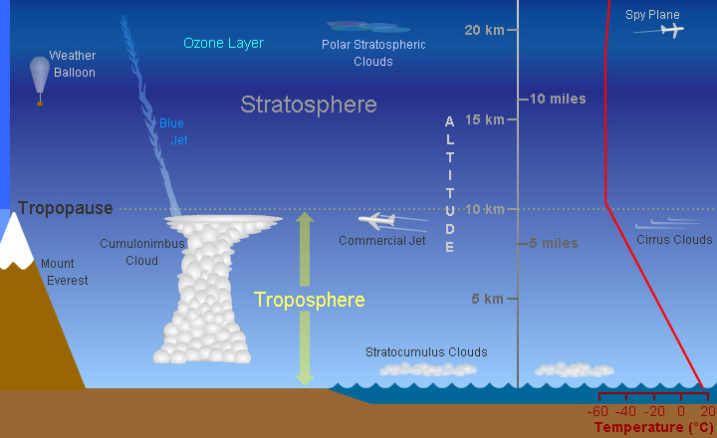

The Stratosphere

The stratosphere is a layer of Earth's atmosphere. The stratosphere is the second layer, as one moves upward from Earth's surface, of the atmosphere. The stratosphere is above the troposphere and below the mesosphere.
The top of the stratosphere occurs at 50 km (31 miles) altitude. The boundary between the stratosphere and the mesosphere above is called the stratopause. The altitude of the bottom of the stratosphere varies with latitude and with the seasons, occurring between about 8 and 16 km (5 and 10 miles, or 26,000 to 53,000 feet). The bottom of the stratosphere is around 16 km (10 miles or 53,000 feet) above Earth's surface near the equator, around 10 km (6 miles) at mid-latitudes, and around 8 km (5 miles) near the poles. It is slightly lower in winter at mid- and high-latitudes, and slightly higher in the summer. The boundary between the stratosphere and the troposphere below is called the tropopause.
Ozone, an unusual type of oxygen molecule that is relatively abundant in the stratosphere, heats this layer as it absorbs energy from incoming ultraviolet radiation from the Sun. Temperatures rise as one moves upward through the stratosphere. This is exactly the opposite of the behavior in the troposphere in which we live, where temperatures drop with increasing altitude. Because of this temperature stratification, there is little convection and mixing in the stratosphere, so the layers of air there are quite stable. Commercial jet aircraft fly in the lower stratosphere to avoid the turbulence which is common in the troposphere below.
The stratosphere is very dry; air there contains little water vapor. Because of this, few clouds are found in this layer; almost all clouds occur in the lower, more humid troposphere. Polar stratospheric clouds (PSCs) are the exception. PSCs appear in the lower stratosphere near the poles in winter. They are found at altitudes of 15 to 25 km (9.3 to 15.5 miles) and form only when temperatures at those heights dip below -78° C. They appear to help cause the formation of the infamous holes in the ozone layer by "encouraging" certain chemical reactions that destroy ozone. PSCs are also called nacreous clouds.
Air is roughly a thousand times thinner at the top of the stratosphere than it is at sea level. Because of this, jet aircraft and weather balloons reach their maximum operational altitudes within the stratosphere.
Due to the lack of vertical convection in the stratosphere, materials that get into the stratosphere can stay there for long times. Such is the case for the ozone-destroying chemicals called CFCs (chlorofluorocarbons). Large volcanic eruptions and major meteorite impacts can fling aerosol particles up into the stratosphere where they may linger for months or years, sometimes altering Earth's global climate. Rocket launches inject exhaust gases into the stratosphere, producing uncertain consequences.
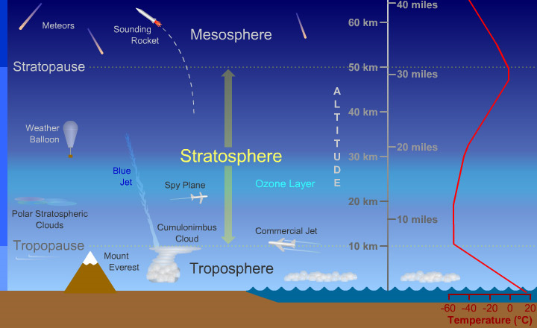

The Mesosphere
The mesosphere is a layer of Earth's atmosphere. The mesosphere is above the stratosphere layer. The layer above the mesosphere is called the thermosphere. The mesosphere starts at 50 km (31 miles) above Earth's surface and goes up to 85 km (53 miles) high.
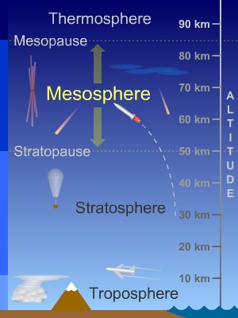
As you get higher up in the mesosphere, the temperature gets colder. The top of the mesosphere is the coldest part of Earth's atmosphere. The temperature there is around -90° C (-130° F)!
The boundaries between layers in the atmosphere have special names. The mesopause is the boundary between the mesosphere and the thermosphere above it. The stratopause is the boundary between the mesosphere and the stratosphere below it.
Scientists know less about the mesosphere than about other layers of the atmosphere. The mesosphere is hard to study. Weather balloons and jet planes cannot fly high enough to reach the mesosphere. The orbits of satellites are above the mesosphere. We don't have many ways to get scientific instruments to the mesosphere to take measurements there. We do get some measurements using sounding rockets. Sounding rockets make short flights that don't go into orbit. Overall, there's a lot we don't know about the mesosphere because it is hard to measure and study.
What do we know about the mesosphere? Most meteors from space burn up in this layer. A special type of clouds, called "noctilucent clouds", sometimes forms in the mesosphere near the North and South Poles. These clouds are strange because they form much, much higher up than any other type of cloud. There are also odd types of lightning in the mesosphere. These types of lightning, called "sprites" and "ELVES", appear dozens of miles above thunderclouds in the troposphere below.
In the mesosphere and below, different kinds of gases are all mixed together in the air. Above the mesosphere, the air is so thin that atoms and molecules of gases hardly ever run into each other. The gases get separated some, depending on the kinds of elements (like nitrogen or oxygen) that are in them.
You know that waves can form in the ocean or other bodies of water. But did you know that there are waves of air in the atmosphere? Some of these waves start in the lower atmosphere, the troposphere and stratosphere, and move upward into the mesosphere. The waves carry energy to the mesosphere. Most of the movement of air in the mesosphere is caused by these waves.

The Thermosphere
The thermosphere is a layer of Earth's atmosphere. The thermosphere is directly above the mesosphere and below the exosphere. It extends from about 90 km (56 miles) to between 500 and 1,000 km (311 to 621 miles) above our planet.
Temperatures climb sharply in the lower thermosphere (below 200 to 300 km altitude), then level off and hold fairly steady with increasing altitude above that height. Solar activity strongly influences temperature in the thermosphere. The thermosphere is typically about 200° C (360° F) hotter in the daytime than at night, and roughly 500° C (900° F) hotter when the Sun is very active than at other times. Temperatures in the upper thermosphere can range from about 500° C (932° F) to 2,000° C (3,632° F) or higher.
The boundary between the thermosphere and the exosphere above it is called the thermopause. At the bottom of the thermosphere is the mesopause, the boundary between the thermosphere and the mesosphere below.
Although the thermosphere is considered part of Earth's atmosphere, the air density is so low in this layer that most of the thermosphere is what we normally think of as outer space. In fact, the most common definition says that space begins at an altitude of 100 km (62 miles), slightly above the mesopause at the bottom of the thermosphere. The space shuttle and the International Space Station both orbit Earth within the thermosphere!
Below the thermosphere, gases made of different types of atoms and molecules are thoroughly mixed together by turbulence in the atmosphere. Air in the lower atmosphere is mainly composed of the familiar blend of about 80% nitrogen molecules (N₂) and about 20% oxygen molecules (O₂). In the thermosphere and above, gas particles collide so infrequently that the gases become somewhat separated based on the types of chemical elements they contain. Energetic ultraviolet and X-ray photons from the Sun also break apart molecules in the thermosphere. In the upper thermosphere, atomic oxygen (O), atomic nitrogen (N), and helium (He) are the main components of air.
Much of the X-ray and UV radiation from the Sun is absorbed in the thermosphere. When the Sun is very active and emitting more high energy radiation, the thermosphere gets hotter and expands or "puffs up". Because of this, the height of the top of the thermosphere (the thermopause) varies. The thermopause is found at an altitude between 500 km and 1,000 km or higher. Since many satellites orbit within the thermosphere, changes in the density of (the very, very thin) air at orbital altitudes brought on by heating and expansion of the thermosphere generates a drag force on satellites. Engineers must take this varying drag into account when calculating orbits, and satellites occasionally need to be boosted higher to offset the effects of the drag force.
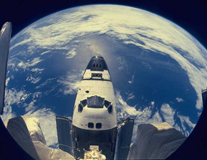
Finally, the aurora (the Southern and Northern Lights) primarily occur in the thermosphere. Charged particles (electrons, protons, and other ions) from space collide with atoms and molecules in the thermosphere at high latitudes, exciting them into higher energy states. Those atoms and molecules shed this excess energy by emitting photons of light, which we see as colorful auroral displays.
This is an image of the space shuttle as it is orbiting around the Earth. The space shuttle orbits in the thermosphere of the Earth.

The Exosphere
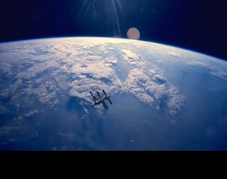
Very high up, the Earth's atmosphere becomes very thin. The region where atoms and molecules escape into space is referred to as the exosphere. The exosphere is on top of the thermosphere. The top of the exosphere marks the line between the Earth’s atmosphere and interplanetary space.
The exosphere is the outermost layer of the Earth’s atmosphere. It starts at an altitude of about 500 km and goes out to about 10,000 km. Within this region particles of atmosphere can travel for hundreds of kilometers in a ballistic trajectory before bumping into any other particles of the atmosphere. Particles escape out of the exosphere into deep space.
The lower boundary of the exosphere, where it interacts with the thermosphere is called the thermopause. It starts at an altitude of about 250-500 km, but its height depends on the amount of solar activity. Below the thermopause, particles of the atmosphere have atomic collisions, like what you might find in a balloon. But above the thermopause, this switches over to purely ballistic collisions.
The theoretical top boundary of the exosphere is 190,000 km (half way to the Moon). This is the point at which the solar radiation coming from the Sun overcomes the Earth’s gravitational pull on the atmospheric particles. This has been detected to about 100,000 km from the surface of the Earth. Most scientists consider 10,000 km to be the official boundary between the Earth’s atmosphere and interplanetary space.

The Ionosphere
Scientists call the ionosphere an extension of the thermosphere. So technically, the ionosphere is not another atmospheric layer. The ionosphere represents less than 0.1% of the total mass of the Earth's atmosphere. Even though it is such a small part, it is extremely important!
The upper atmosphere is ionized by solar radiation. That means the Sun's energy is so strong at this level, that it breaks apart molecules. So there ends up being electrons floating around and molecules which have lost or gained electrons. When the Sun is active, more and more ionization happens!
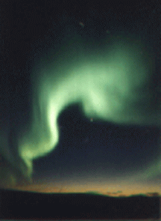
Different regions of the ionosphere make long distance radio communication possible by reflecting the radio waves back to Earth. It is also home to auroras.
Temperatures in the ionosphere just keep getting hotter as you go up!

FILL-IN-NOTES
I. Earth’s Atmosphere
A. Importance of the Atmosphere
1. The atmosphere __________________________________________________________________________________ __________________________________________________________________________________________________.
2. If there wasn’t an atmosphere there would be extremely ________________ and extremely ____________________.
3. The atmosphere ____________________________ between these because it ____________________________ heat.
4. It also ___________________ from some of the _____________________________________.
B. What the atmosphere is made of…
1. The Earth’s atmosphere is a ___________________________________________________ that surrounds the planet.
2. The atmosphere ___________________________________________________ and extends to __________________.
3. The Earth has had ______________________________________ since its creation.
C. Gases in the Today’s Atmosphere
_____%_________________
_____%_________________
_____%_________________mostly Argon, Carbon Dioxide, and Ozone
As much as ____% of all gases are _____________________
1. Changes in the atmosphere
a. Because of the _____________________________________________ pollutants like large amounts of ____________ ___________________ are being released into the atmosphere.
b. Pollutants mix with ___________________________________________________.
c. This forms after cars emit _________________________, ____________ is burned for heat or electricity,_______ is burned to heat homes etc.

2. Solids and Liquids in the Atmosphere
a. Earth’s atmosphere also contains ___________________________ such as _________, _________, and ___________.
Dust ____________________ Salt from __________________ Pollen_____________
b. _____________________________are also in the atmosphere and get there after ____________________________.
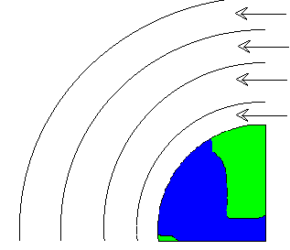
_________________________ from eruptions
D. Layers of the Atmosphere

E. Atmospheric Pressure
1. Atmospheric gases extend way above the Earth’s surface. When _________________________ down on these molecules the ___________________________________________ on the air below. This causes _________________.
2. AIR PRESSURE __________________ AS YOU GO __________________ IN THE ATMOSPHERE.
3. AIR PRESSURE __________________ AS YOU GO __________________ IN THE ATMOSPHERE.
~So, it is harder to breathe at high altitudes because less air molecules.
~Your ears ‘pop’ going down mountains because of the change in air pressure.
F. The Ozone Layer
1. The ozone layer is _________________________________ with a lot of ozone that _______________ most of the sun’s harmful radiation.
2. Ozone is made up of ____________________________. (The air you breathe is only 2 oxygen atoms together.)
3. Ozone absorbs most _________________________________ that enters the atmosphere.
4. Ultraviolet radiation causes _______________________ and can lead to ____________________.
5._____________________ can damage the ozone layer. _________________________________are examples of pollutants destroying ozone. When pollutants destroy ozone this leaves a _____________________________________.
6. The Hole in the ozone layer _________________________ which is harmful. And this also contributes to ____________________________________.

